Roundtable discussion about the effective integration of biodiversity to the food supply chains related to ecological and traditional (low input) cereals

Location: University of Debrecen
Date: 16th April 2018
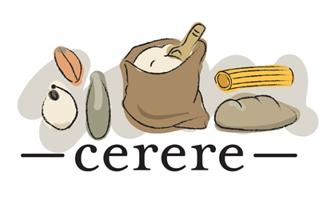

The Institute for Land Utilisation, Regional Development and Technology of the Faculty of Agricultural and Food Sciences and Environmental Management and the Institute and the Institute of Marketing and Trade of the Faculty of Economics of the University of Debrecen organised a roundtable discussion on 16th April 2018 about the bottlenecks and challenges observed during the „farm to fork” process of ecological and traditional (low input) cereals. The event was organised within the framework of the H2020 project „CERERE”. The aim of the project is to examine the integration of biodiversity to the food supply chains related to ecological and traditional (low input) cereals.
During the discussion, prorector Prof Dr. János Nagy presented the activities of the Institute of Land Utilisation, Regional Development and Technology from the aspect of CERERE. Dr. Zsolt Polereczki, associate professor of the Institute of Marketing and Trade outline mechanism of CERERE in detail. The representatives of the various invited organisms talked about the opportunities of their institutes in relation to the project, including the József Zsembeli, the director of the Karcag Research Institute of the University of Debrecen. On behalf of NÉBIH (National Food Chain Safety Office), Bernát Poós presented the system of variety classification of quality wheat varieties. Mária Dani held a presentation about about the policy of Biokontroll Hungária concerning landrace and low input cereal production. Lajos Horváth, department head of the Crop Diversity Centre outlined the gene bank activity performed by the organisation. Eventually, the participants of the roundtable discussion – many of whom are organic producers – discussed the main points of the presentations and engaged into conversation about the current difficulties faced by organic and ecological production and their possible solutions.

